(Approx. 1646 words)

President's Corner
Smart Home, Smarter Home
by Greg Skalka, President, Under the Computer Hood User Group
www.uchug.org
president (at) uchug.org

Everyone wants some control in their lives. Having the ability to control things in our homes can provide added safety, security, and convenience. Technology to enable consumer home automation and control has been around for decades and is constantly improving. It can provide useful assistance to those with disabilities involving hearing or sight loss, or those with reduced mobility. Home automation and smart home technologies can provide benefits as we get older, allowing us to stay in our homes longer. As we spend more of our time at home due to the coronavirus, a smart home can be brilliant.

The desire for home control has been around for a long time. Ever since the early days of TV, when viewers wished they did not have to get up out of their La-Z-Boy recliners to turn the knob on the set to change to the other channel (I was once told by someone that was what children were for), there has been a market for remote control. Remote controls became popular for televisions, entertainment systems, and garage door openers. What many longed for was a remote control for our houses.

One of the first and most popular home automation systems was the X10 line of devices, which was introduced in the late 1970s. They were sold under many names over the years, including X10, Radio Shack, Leviton, Sears, Stanley, Black & Decker, IBM, RCA, GE Homeminder, and Smarthome, and the company passed through many owners. X10 products and systems are still available, mainly through the x10.com website. For more information, look up X10 on Wikipedia.

I was interested in home control and so became an early adopter in the early 1980s. The devices were relatively inexpensive and systems could be pieced together, making it easy to get started in this addicting hobby. I bought many devices and controllers over the years, including alarm systems and computer interfaces, many of which I still have.

X10 is a fairly simple system that works reasonably well. Like the Smart Home Wi-Fi devices popular today, X10 has control devices that range from plug-in modules that items to be controlled plug into wired-in house switch replacements. There are many types of controllers, from plug-in boxes and timers to computer interfaces and alarm consoles. Almost everything was compatible with everything else; you could have as many controllers as you wanted and could control up to 256 devices in a house.

X10 was easy to use but did have some significant limitations. The control signals were transmitted by modulating digital data onto the house power wiring, so system setup was as easy as plugging things in. The data rates it used were low (20 bits/second), so control messages were very simple (the device address and basic commands like on and off). It did have problems getting messages through reliably, as the 120 kHz carrier frequency it used often received interference from household devices like televisions and computers. It also didn’t handle passing signals between the two 120-volt legs in typical home wiring very well. They sell devices to bridge between the two-house circuits, but even then I often had problems transmitting between certain locations in my house.

At my X10 peak, I had about 16 controlled devices, with ten of them wired-in switch modules. Since X10 was constrained to your house wiring, control was limited to immediate control while in your home, or timers. There were wireless remote controls, but these transmitted a short-range RF signal to a plugged-in receiver module, which then transmitted control signals over the house wiring. I did have a phone controller, which consisted of a base module connected to my phone line and a battery-powered transmitter (about the size of a flip phone). I remember using it in the late 1980s to turn on the power to my garage door opener from my work (I had plugged my opener into an X10 module). I had a timer controller shut off my opener power after I left for work, but because the time I returned home was often variable, I used this phone device to turn the opener back on. At the end of my workday, I could call my home phone from work, and then once my answering machine is picked up, use this hand-held transmitter to send audio signals over the phone to the module in my home. It decoded the sounds and sent signals over the power lines to turn on the opener. It may seem crude by today’s standards, but it was pretty impressive to be able to do that at the time.
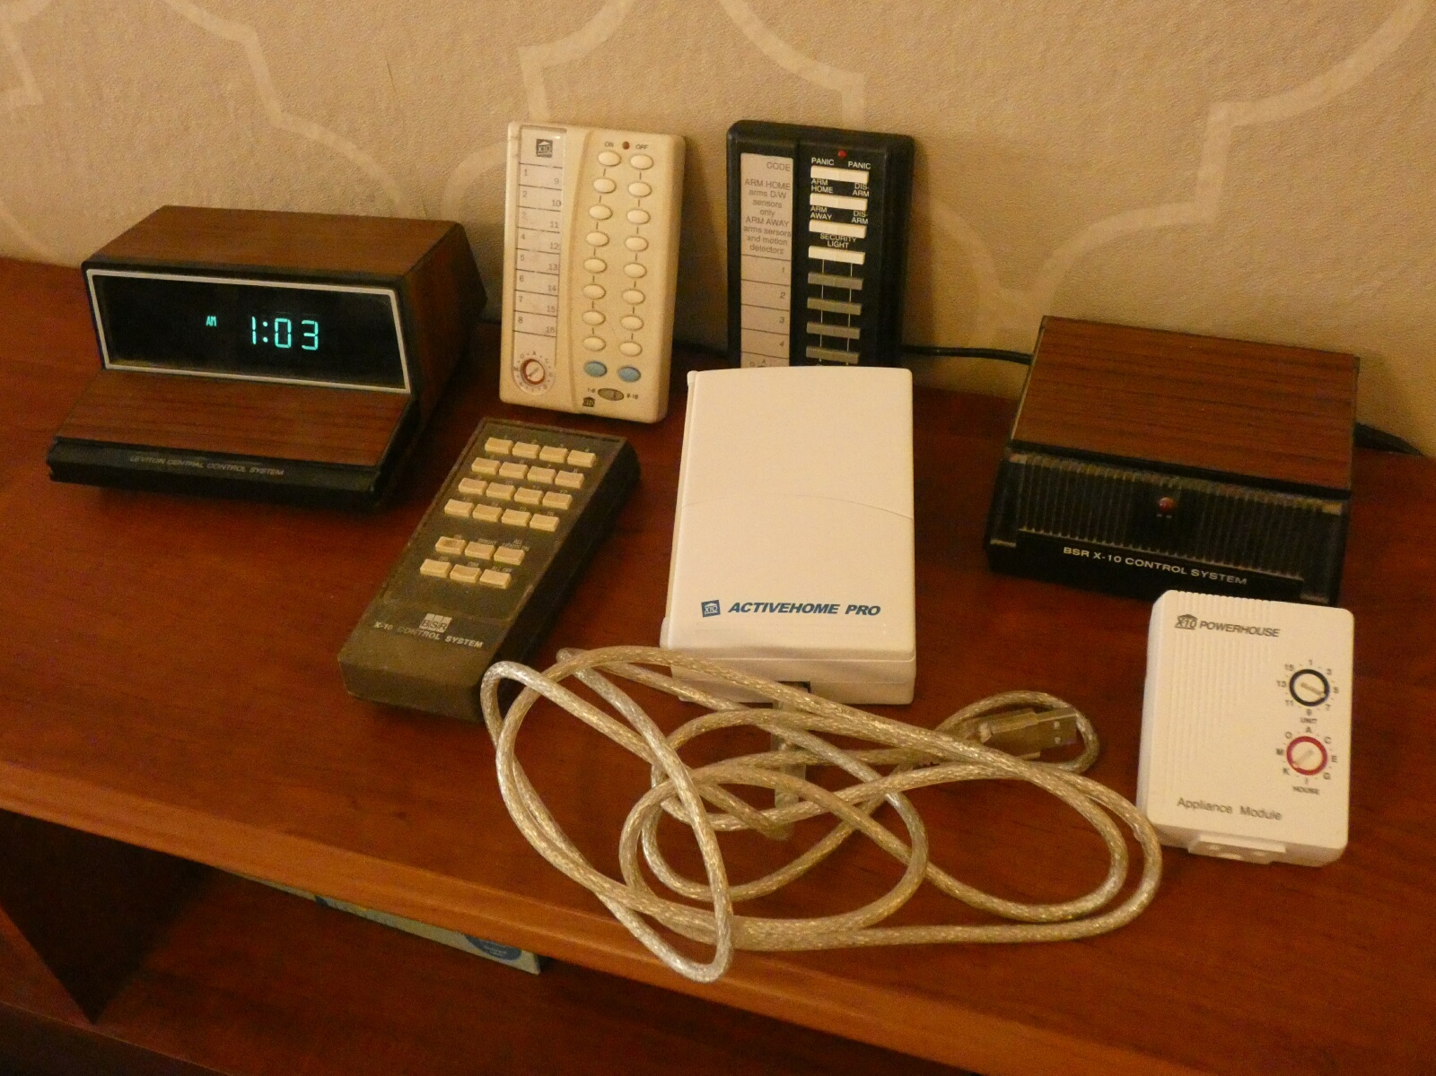
X10 Devices
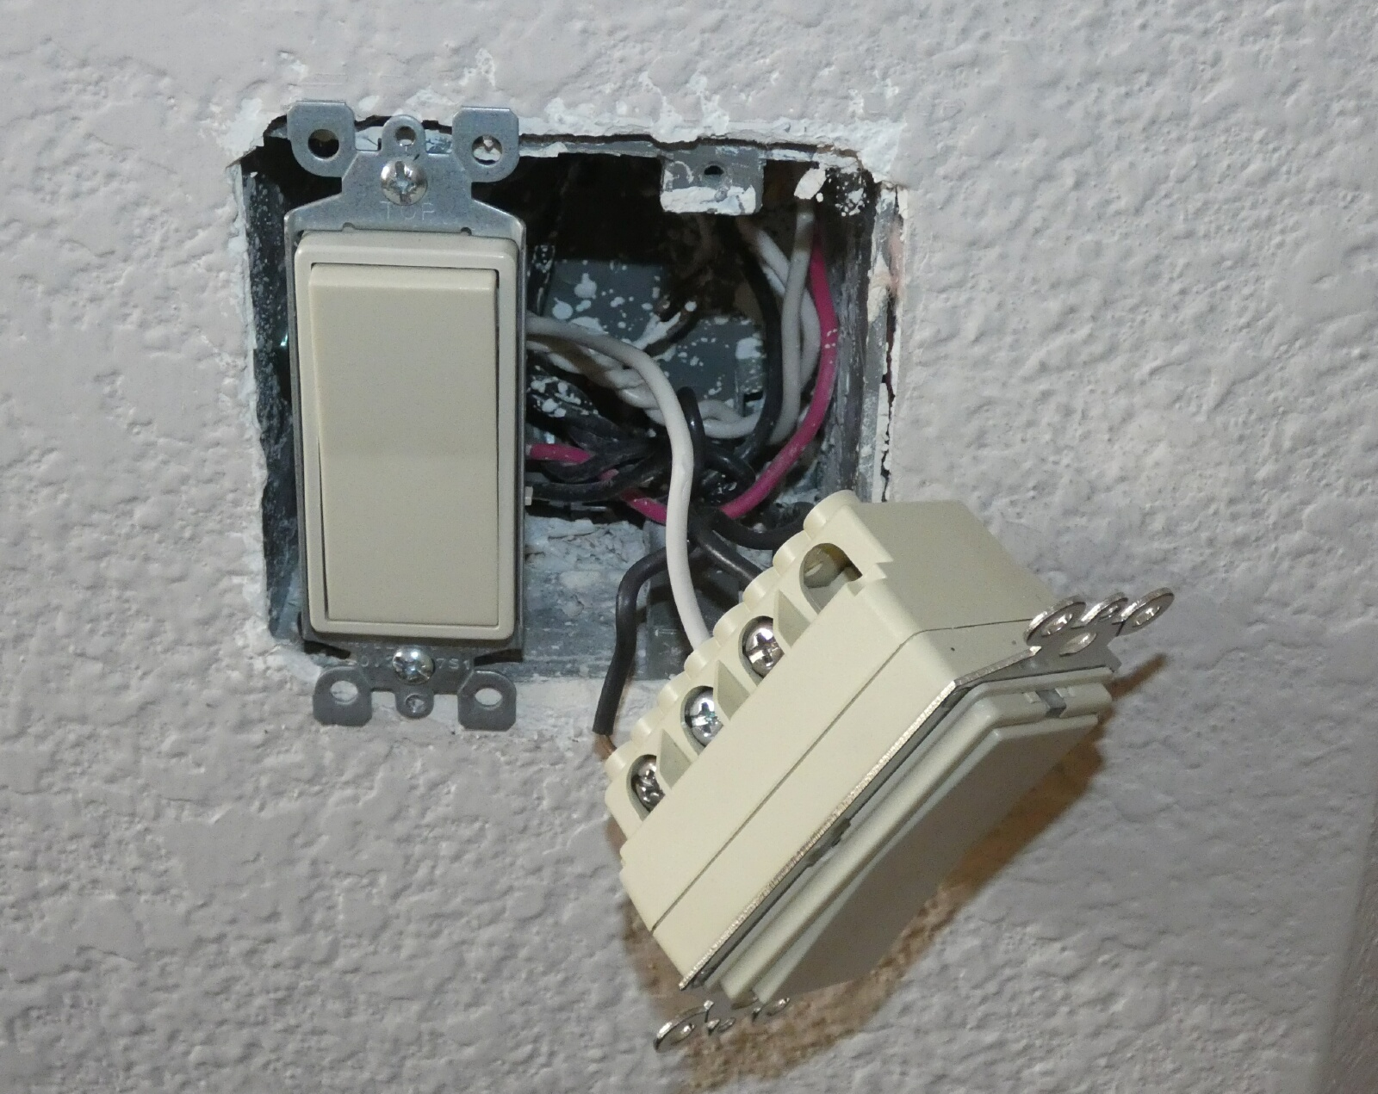
Removing X10 Switch
Today, of course, all smart home devices can be controlled from almost anywhere in the world through apps on your smartphone. Most smart home components communicate through Wi-Fi so are not tied to house wiring and have more reliable and sophisticated control (a few devices use Bluetooth or Zigbee and need a hub to connect to Wi-Fi).
In addition to your phone, smart speakers like Amazon’s Echo (Alexa) or Google’s Home Assistant can be used to control your home.

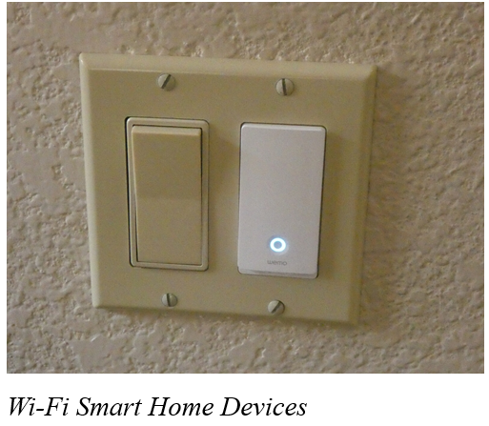
I started buying Wi-Fi smart home devices soon after getting a smartphone. Once again, I was able to buy gradually, building up my new smart home over time. My first device was a Belkin WeMo smart plug; a plug-in module I use to control a table lamp. I now have seven devices installed to control lights; these include smart plugs, smart bulbs, and most recently a smart switch. I retired my X10 plugs some time ago; I’m now starting to replace the wired-in switch modules. Even though the X10 stuff still works, the allure of more sophisticated control through Wi-Fi and Alexa will I’m sure have me replace it all eventually.

That’s not to say that there no downsides to the new Wi-Fi smart home devices. With X10, almost everything worked with everything else. Different parts from different vendors all played together nicely. With Wi-Fi smart home devices, this is only partially true. My seven smart home devices come from three different vendors (Belkin WeMo plugs, TP-Link smart bulbs, and Feit smart bulbs and plugs). Each vendor requires its own app for control on my phone. Each app is different and some are better than others. The one unifying factor is Alexa; almost all devices are compatible with the three voice-operated assistants (Amazon Alexa, Google, and Apple). This app-happy situation also applies to my smart cameras and smart thermostat, which add another five apps to my phone. Fortunately, Alexa can control my thermostat and two of my four brands of cameras.
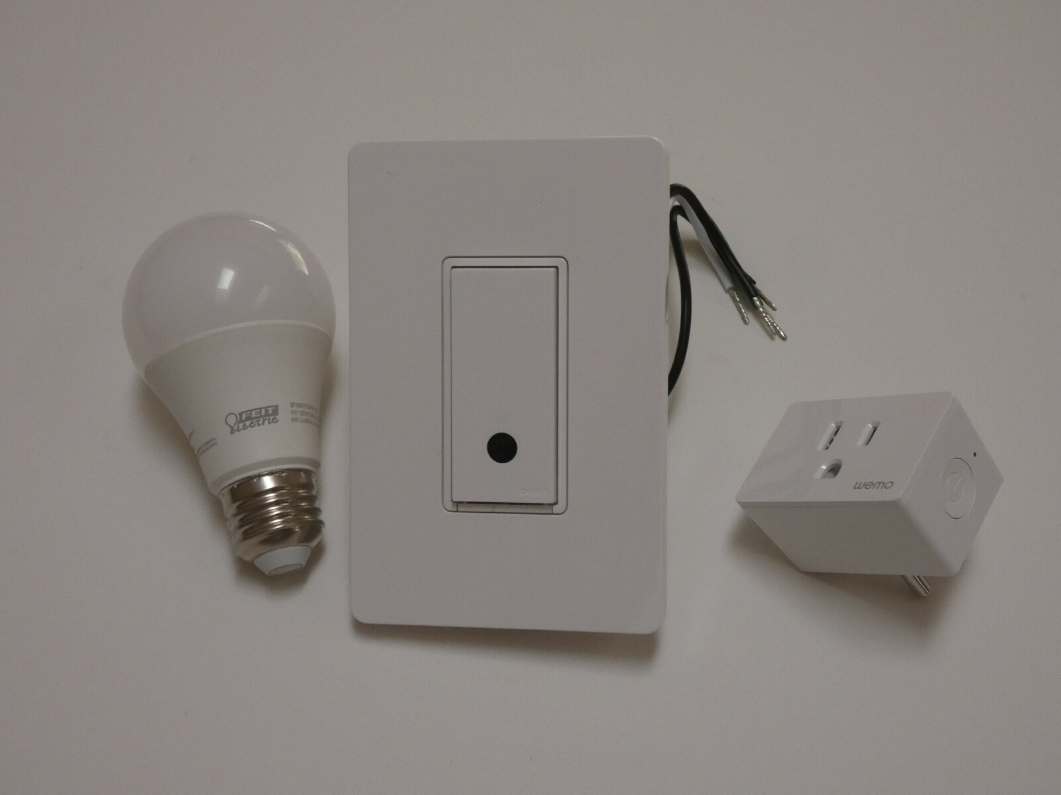
Wi-Fi Smart Home Devices

Another concern I have about Wi-Fi smart home products is security. In my old X10 smart home, it would be hard to hack my home unless someone physically plugged into a power outlet (kind of like the superior security of wired Ethernet compared to Wi-Fi). It might be possible to send or receive the power line signals in an adjacent house, but unlikely. A bigger concern is that the apps or servers of the many product vendors and Amazon might get hacked. As long as I’m only controlling lights (and not my chipper/shredder), the biggest hack risk is probably to my privacy.

One good reason to phase out my X10 stuff is batteries. All of the X10 wireless remotes use batteries. I’ve had to throw away many remotes over the years because the batteries in them (AAA, AA, or 9V) had leaked. Almost all my new smart home devices use house power. While cords can be a nuisance, corded devices don’t die from leaking batteries.

Smart home technology is beneficial if it makes your life better. A prime task my X10 system used to perform was to make our house look occupied when we were away on a trip. Though we travel much less in COVID times, I can do that with my Wi-Fi smart home devices, though I must set it up using three phone apps.

Recently I’ve been improving my life through light control in the mornings. I normally get up for work at 4:30 AM, while my wife usually sleeps in until after I’ve left the house. I try to keep quiet and keep lights off so I don’t wake her, but have found it can be dangerous to walk around the house (especially down the stairs) in the dark. I have now set a light in my office to come on about 5 minutes before I would come out of the bedroom, so I have at least a little light to guide me. I’ve programmed another lamp downstairs to come on a little later so that after I’ve taken my online COVID health assessment for work and checked my emails, I can go downstairs and see the stairs. I could tell Alexa to shut off the lights behind me, but my wife might hear that. Instead, I use the video screen on my new 5” Amazon Echo Show to silently turn off those lights. I can even turn up the heat on the thermostat a bit so my wife will have it a bit warmer when she gets up, and then set the thermostat back down on my smartphone when I get to work.

With X10, my home over the years may have been smarter than most. Now with these improved smart home devices replacing X10, my home has gotten even smarter. With my smartphone, Amazon Echo, and Echo Show, I can control things away from home, or at home by voice or by touch. With voice control and touch control of my home, what can be next? I wonder if Jeff Bezos is working on Amazon Echo Think.
Greg

